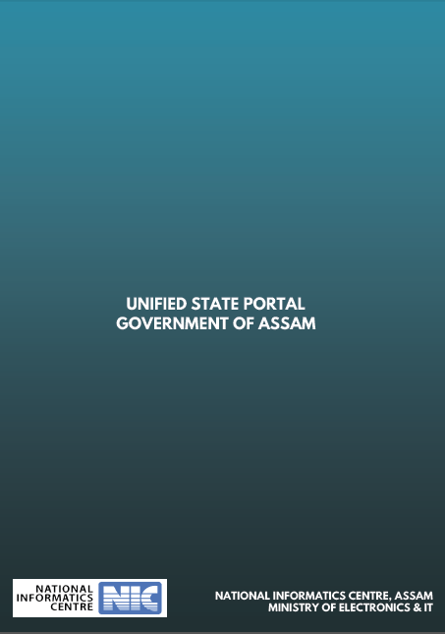

Functional Requirement Specifications for Document Exchange System (DES)

Version 0.1
Web Development Cell

Confidentiality Statement

This document contains information that is proprietary and confidential to National Informatics Centre (NIC), Assam which shall not be disclosed, transmitted or duplicated, used in whole or in part for any purpose other than its intended purpose. Any use or disclosure in whole or in part of this information without written permission of National Informatics Centre (NIC), Assam, Ministry of Electronics & Information Technology, Govt. of India is prohibited.

Copyright 2017, National Informatics Centre (NIC), Assam

Document prepared by | Tapan Kr. Gogoi, Scientist-F, NIC  Anuradha Barua, Scientist-E, NIC  Aziza Yasmin Rahman, Scientist-D, NIC  Niraj Jalan, System Administrator, WDC
Version | 0.2
Reviewed by | Suchitra Pyarelal, Scientist-F, NIC
Date | 28-11-2017

Contents

1. Executive Summary 6
2. Scope 6
3. Assumptions 6
4. User Requirements 6
5. Functional Requirements 7
6. Non Functional Requirements 7

Executive Summary

Document Exchange System forms the Integral part of the Unified State Portal. In Government, documents provide evidence to justify government decisions. All Departments, Sub-Departments, District, etc keep their documents in their website portal. These documents however may be relevant to other Departments and the State Portal. So there must be a Unified System for searching a document published in various Department websites as well as in the State Portal.

Document Exchange system is needed to transfer all the documents along with the metadata to the Unified State Portal from various Department websites in order to have a Unified Search. Document Exchange system should be capable of exchanging documents throughout their lifecycle, while retaining integrity, authenticity and accessibility.

Scope

This document covers the requirements for Document Exchange System for all documents of the Government of Assam, from different Department/Sub-Department websites to Unified State Portal.

Assumptions

Users of Document Exchange System would be Authenticated Government users who will be involved in the building up of the document repository. These users could be from a State level department, any subordinate organization or any district or sub-district level office.

We may also assume that persons or users involved in the support or the building up of the document repository are aware of the key points to be kept in mind while sharing of documents.

User Requirements

A user may require transfer of published documents from State Portal to other portals like Department, sub-department, district portals and vice versa.

Transferred From | Transferred to
Department Portal | State portal
Sub-organisation Portal | State portal
District Portal | State portal
State portal | Department Portal
State portal | Sub-organisation Portal
State portal | District Portal

Functional Requirements

- The system should facilitate exchange of shared and published documents between USP and Other Portals. The other portals may be department, sub-department or district portals.
- The websites of various departments, sub-departments or districts may reside in different clouds/ Data Centres.
- The document transfer should be done using open architecture and open exchange standards mechanism.
- The system should provide Document transfer mechanism from USP to Other Portals.
- The system should provide Document transfer mechanism from Other Portals to USP as well.
- The system should able to check duplicity in transferring document and should alert the concerned people.
- The document transferred should be searchable from both the websites.
- The system should ensure that the document is exchanged successfully. There should be an acknowledgement/ handshaking from the receiver in document transfer.
- In case of failure of document transfer an alert/notification should be sent to the concerned users.
- The user should be able to initiate the document transfer for failed exchange anytime.
- The user should be able to set priority to the documents to be transferred based on the urgency of the document.
- The document should be transferred based on the document priority. The high priority document should be transferred before the low priority documents. Sometimes documents may need to be transferred instantaneously.

Non Functional Requirements

- The system should be able to transfer documents such that the content and properties of the documents are not degraded.
- The interface used for document exchange system should be made simple and intuitive.
- Context Help should be available for each field.
- Tooltips to be made available for each field.
- The exchange should be fast.
- Document exchange should be secured.
- In multiple document exchange performance of the system should not be hampered.

Technology Support Group, Unified State Portal
Web Development Cell
Room No. 006, CM Block, Ground Floor
Assam Secretariat

